

Definition:



**Example:** 2.2: An experiment consists of flipping a coin and then flipping it a second time if a head occurs. If a tail occurs on the first flip, then a die is tossed once. Write the sample space of the experiment.

S = {HH, HT, T1, T2, T3, T4, T5, T6}

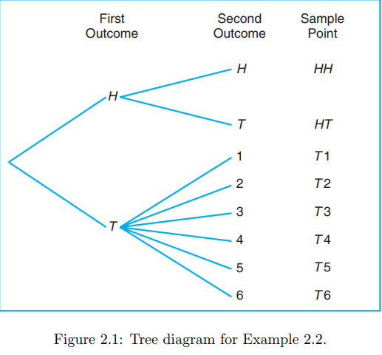

Que 2.5: An experiment consists of tossing a die and then flipping a coin once if the number on the die is even. If the number on the die is odd, the coin is flipped twice. Using the notation 4H, for **Example:**, to denote the outcome that the die comes up 4 and then the coin comes up heads, and 3HT to denote the outcome that the die comes up 3 followed by a head and then a tail on the coin, construct the sample space S.

Que 2.5: An experiment consists of tossing a die and then flipping a coin once if the number on the die is even. If the number on the die is odd, the coin is flipped twice.

1. What is the probability of the event that the number on the die is less than 3?
2. What is the probability of the event that the two tails occur?



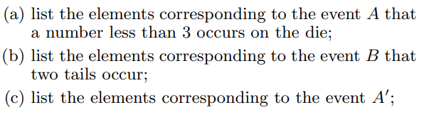

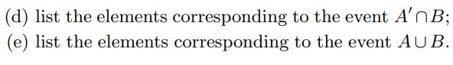

**Example::**



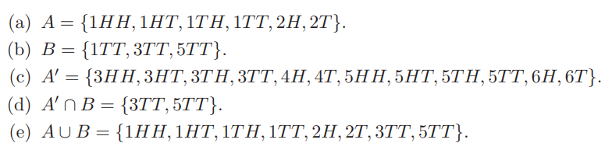

Que. 2.7 Four students are selected at random from a chemistry class and classified as male or female. List the elements of the sample space S1, using the letter M for male and F for female. Define a second sample space S2 where the elements represent the number of females selected.

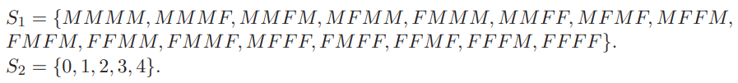

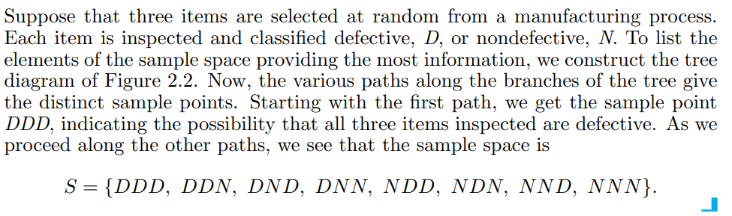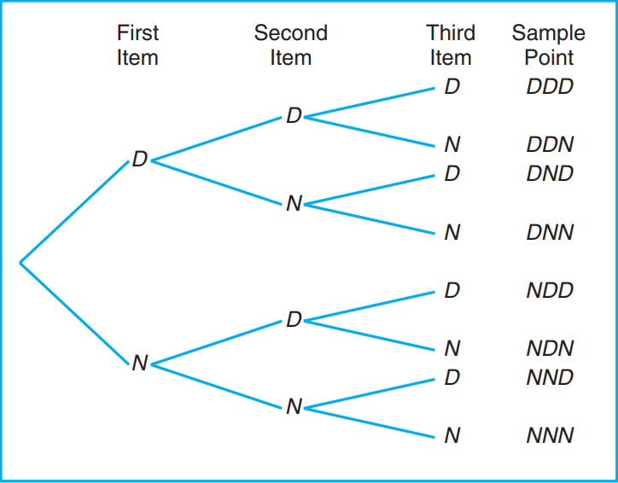

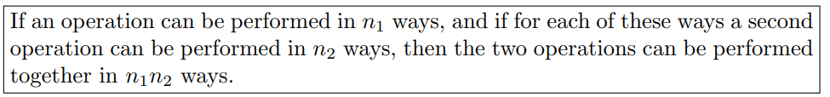

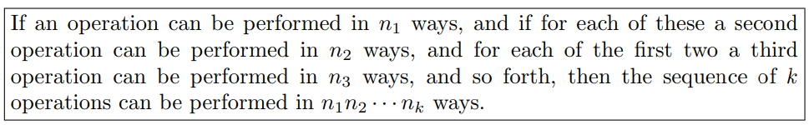

**Example:**

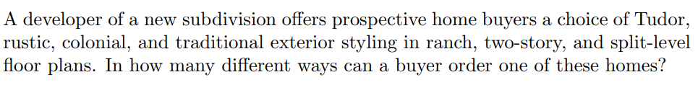

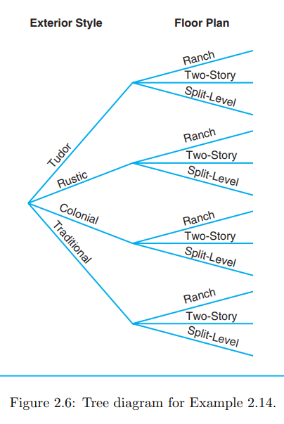

**Example::**



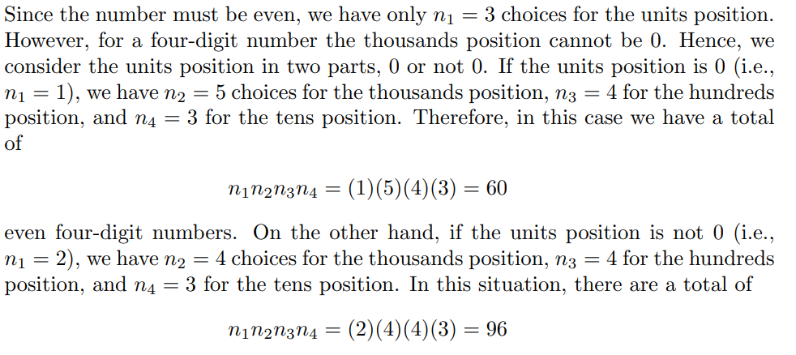

Definition 2.7: A permutation is an arrangement of all or part of a set of objects.

Theorem 2.1: The number of permutations of n objects is n!.

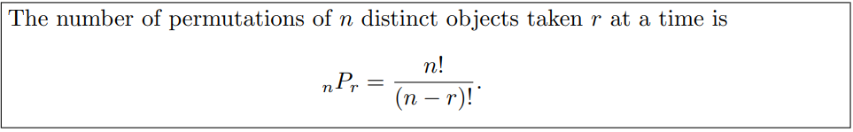

**Example::**

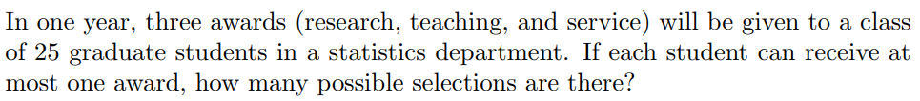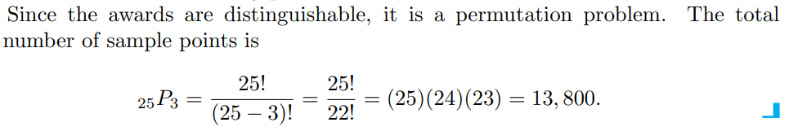

**Example::**

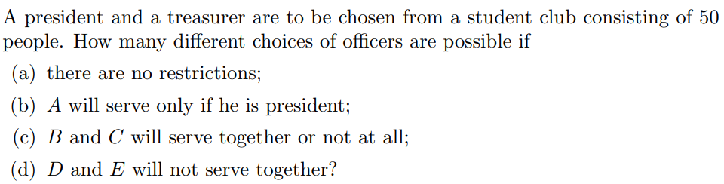

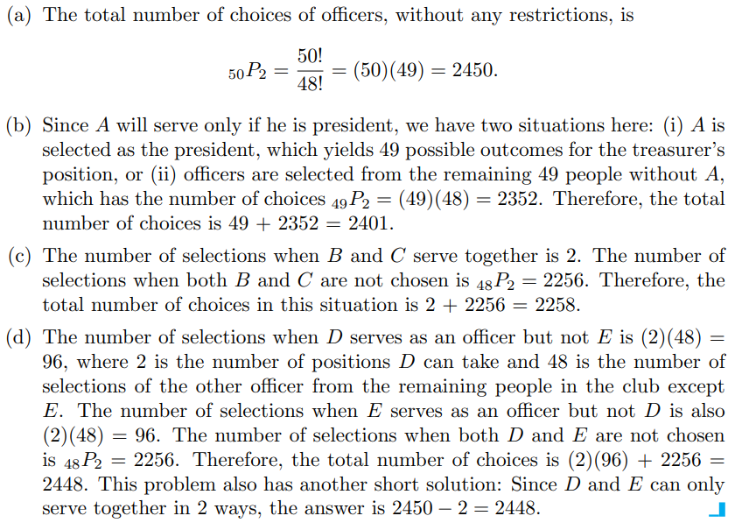

Theorem 2.3: The number of permutations of n objects arranged in a circle is (n − 1)!.

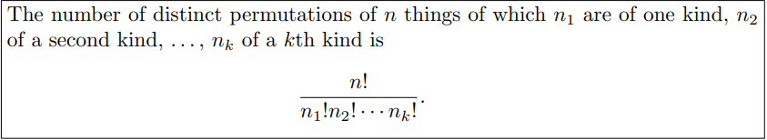

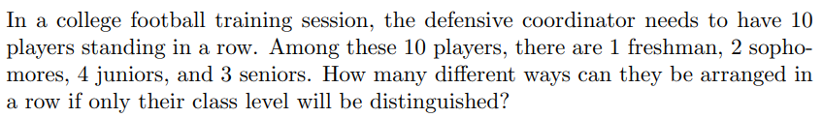

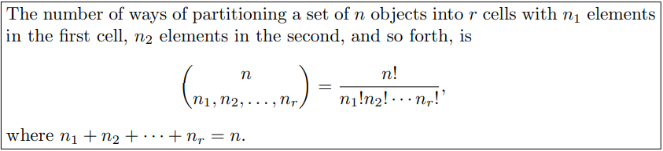

**Example:** 2.21: In how many ways can 7 graduate students be assigned to 1 triple and 2 double hotel rooms during a conference?

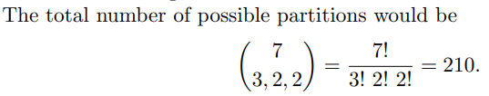

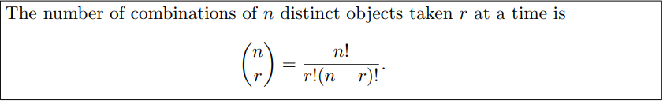

Que. A college plays 12 football games during a season. How many ways can the team end the season with 7 wins, 3 loses, and 2 ties?

**Example:** A young boy asks his mother to get 5 Game-Boy cartridges from his collection of 10 arcade and 5 sports games. How many ways are there that his mother can get 3 arcade and 2 sports games?

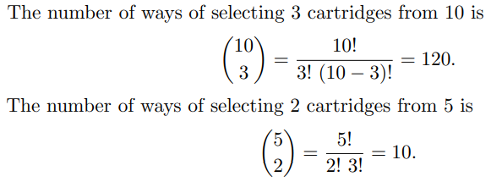



**Example:** How many different letter arrangements can be made from the letters in the word STATISTICS?

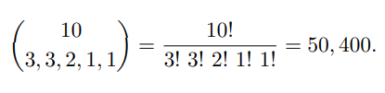

**Example:** In a random arrangement of the letters of the word ‘COMMERCE’, find the probability that all the vowels come together.

**Example:** ‘7’ persons are seated on ‘7’ chairs around a table. The probability that three specified persons are always sitting next to each other is:

(a)1/4                    (b)1/5                 (c)1/6                    (d) 1/3.

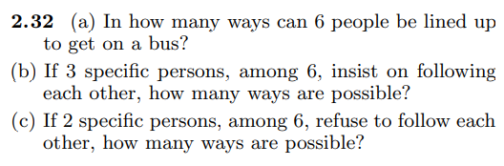

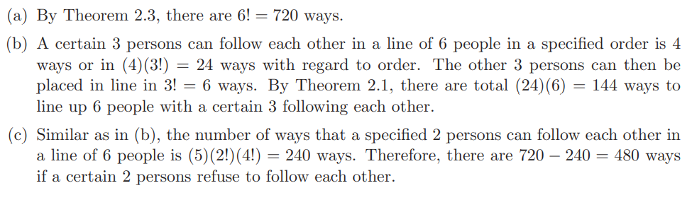

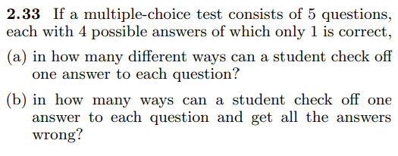

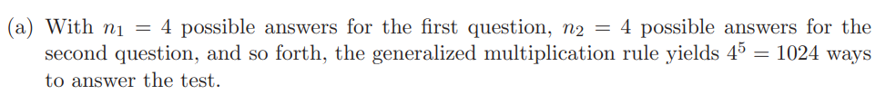

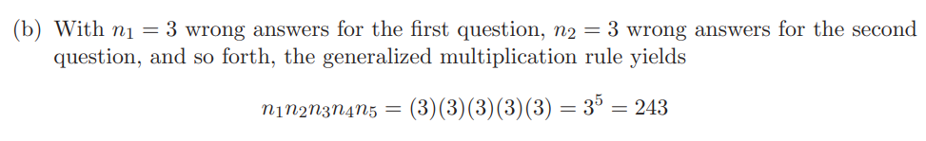

**Example:** In a poker hand consisting of 5 cards, find the probability of holding 2 aces and 3 jacks.

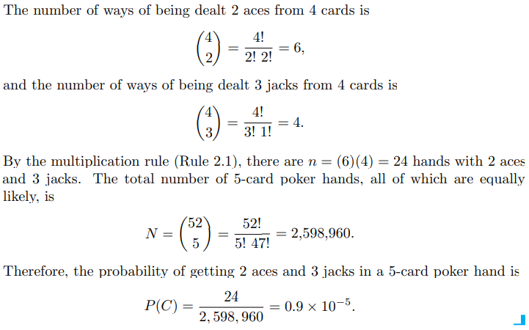

Q. A man is dealt/ given 5 hearts cards from a pack of 52 cards. If he is given 4 more additional cards, then the probability that at least one of the additional cards is also a heart is:

(a) 39C4/52C5 (b)1-(39C4/47C4) (c)39C4/47C4  (d) None of these.

Q. In how many ways can 4 boys and 5 girls sit in a row if the boys and girls must alternate?

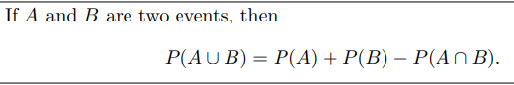

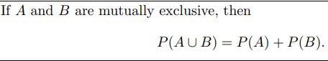

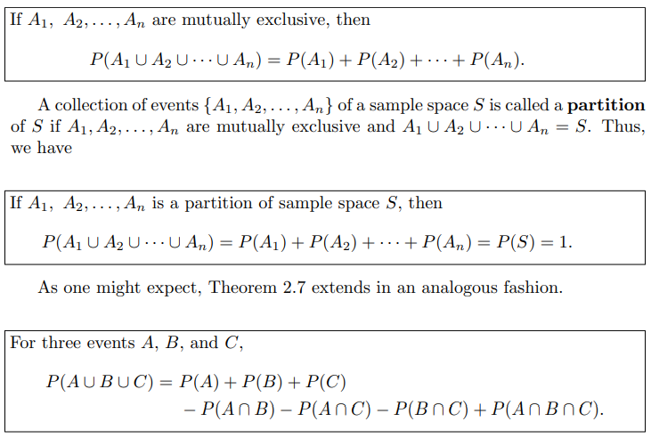

**Example:** An MBA applies for a job in two firms X and Y. The probability of his being selected in firm X is 0.7, and being rejected at firm Y is 0.5.The probability of at least one of his applications being rejected is 0.6. What is the probability that he will be selected in one of the firms?

(a) 0.2                    (b) 0.8                 (c) 0.7                    (d) None of these.

**Example:** A,B,C are three mutually exclusive and exhaustive events associated with the random experiment. Given that $P\left(B\right)=\frac{3}{2}P\left(A\right)$ and $P\left(C\right)=\frac{1}{2}P\left(B\right)$ then $P\left(A\right)=?$

(a) 4/9                    (b) 9/13                 (c) 4/13                    (d) None of these.

Que. Suppose that in a senior college class of 500 students it is found that 210 smoke, 258 drink alcoholic beverages, 216 eat between meals, 122 smoke and drink alcoholic beverages, 83 eat between meals and drink alcoholic beverages, 97 smoke and eat between meals, and 52 engage in all three of these bad health practices. If a member of this senior class is selected at random, find the probability that the student

(a) Smokes but does not drink alcoholic beverages;

(b) Eats between meals and drinks alcoholic beverages but does not smoke;

(c) Neither smokes nor eats between meals.

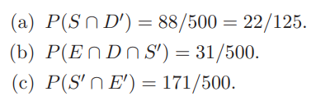

Que. In a high school graduating class of 100 students, 54 studied mathematics, 69 studied history, and 35 studied both mathematics and history. If one of these students is selected at random, find the probability that (a) the student took mathematics or history; (b) the student did not take either of these subjects; (c) the student took history but not mathematics.

Que. If five dice are rolled, what is the probability of getting four of a kind?

$$\frac{C\left(5,4\right)*6*5}{6^{5}}$$

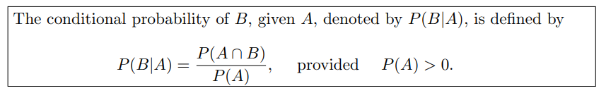

Example: The probability that a regularly scheduled flight departs on time is P(D)=0.83; the probability that it arrives on time is P(A)=0.82; and the probability that it departs and arrives on time is

P(D ∩ A)=0.78. Find the probability that a plane

(a) arrives on time, given that it departed on time,

(b) departed on time, given that it has arrived on time.

(c) arrives on time, given that it has not departed on time

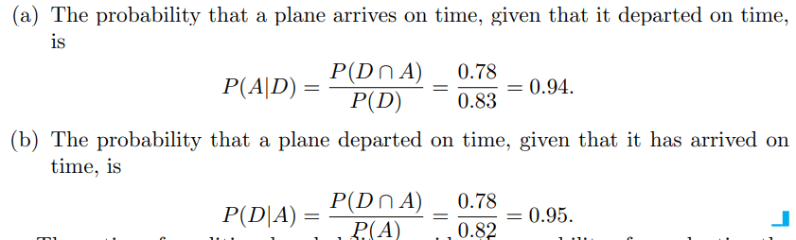

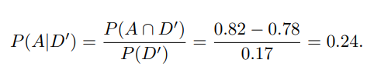

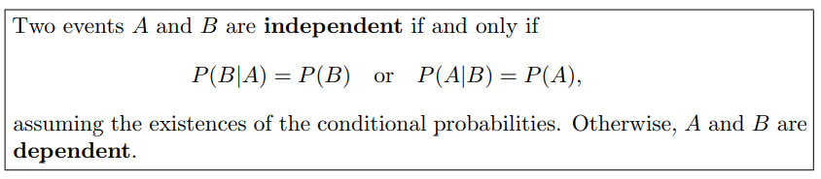

Q. Which of the following statements is/are correct?

(i) If events $A$ and $B$ are mutually exclusive then $P\left(A∩B\right)=P\left(A\right)P(B)$

(ii) If events $A$ and $B$ are mutually exclusive then $P\left(A∪B\right)=P\left(A\right)+P(B)$

(iii) If events $A$ and $B$ are mutually independent then $P\left(A∩B\right)=P\left(A\right)P(B)$.

(a) option (i) is correct only (b) option (ii) is correct only

(c) both options (ii)and (iii) are correct only

(d) option (iii) is correct only.

Example: Suppose that we have a fuse box containing 20 fuses, of which 5 are defective. If 2 fuses are selected at random and removed from the box in succession without replacing the first, what is the probability that both fuses are defective?

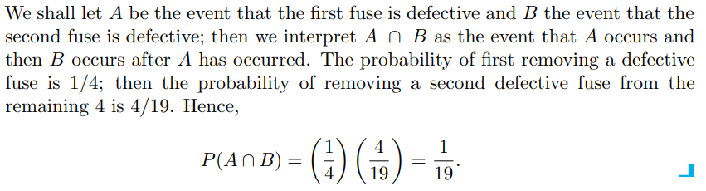

Example: One bag contains 4 white balls and 3 black balls, and a second bag contains 3 white balls and 5 black balls. One ball is drawn from the first bag and placed unseen in the second bag. What is the probability that a ball now drawn from the second bag is black?

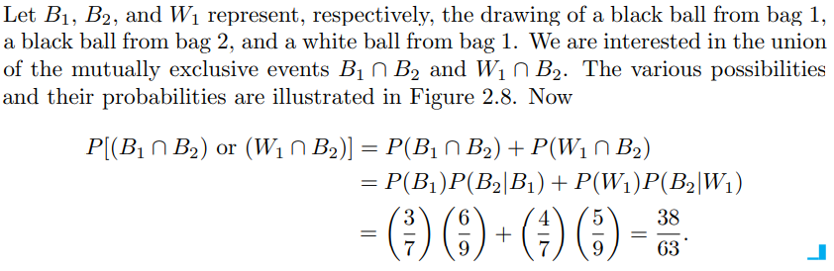

Example: An electrical system consists of four components as illustrated in Figure. The system works if components A and B work and either of the components C or D works. The reliability (probability of working) of each component is also shown in Figure. Find the probability that

(a) the entire system works and

(b) the component C does not work, given that the entire system works. Assume that the four components work independently.

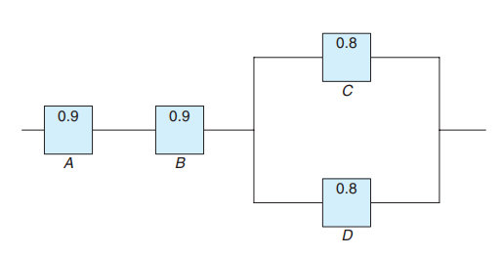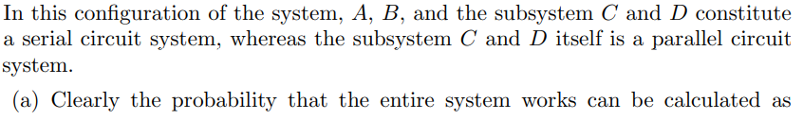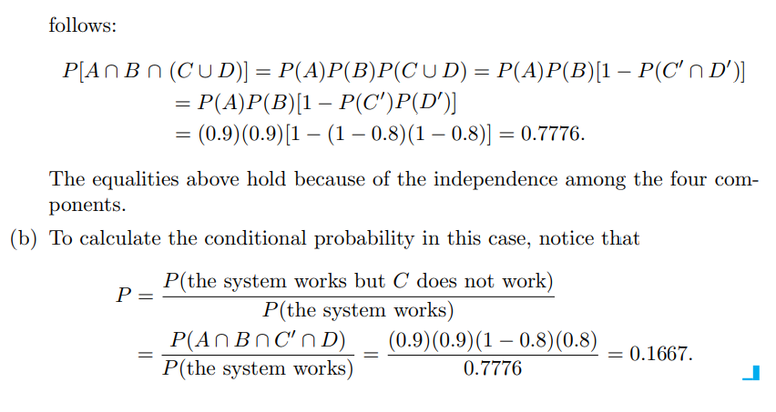

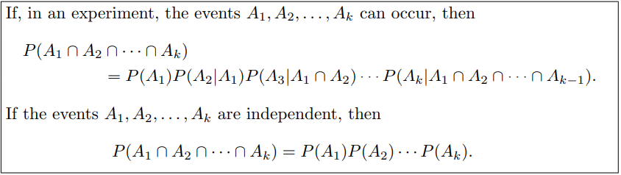

**Example:**

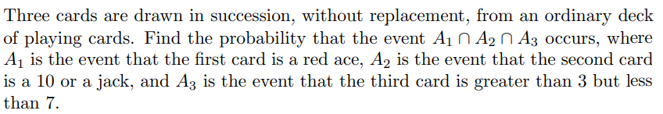

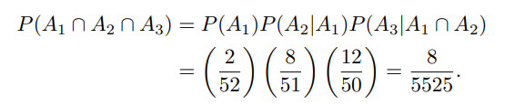

**Theorem of total probability or the rule of elimination**

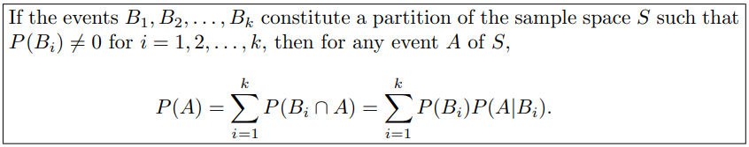

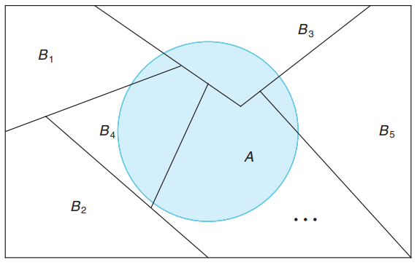

**Example:**

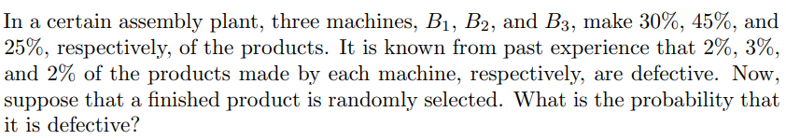

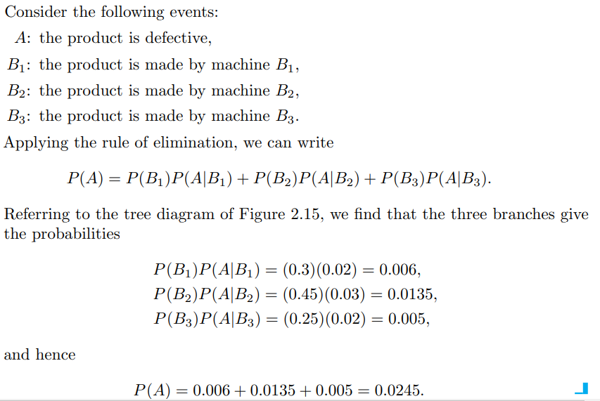 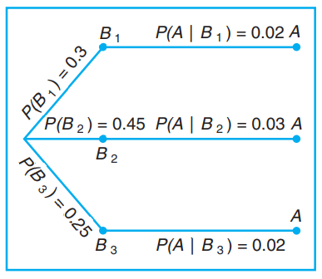

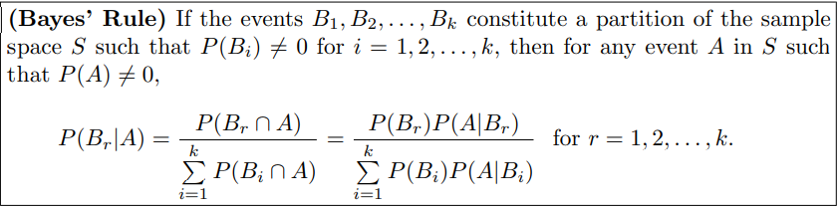

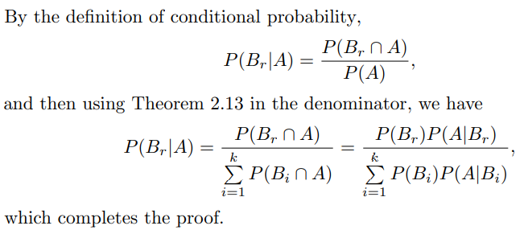

**Example:**



**If a product was chosen randomly and found to be defective, what is the probability**

**that it was made by machine B3?**

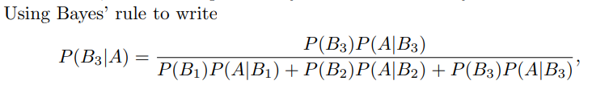 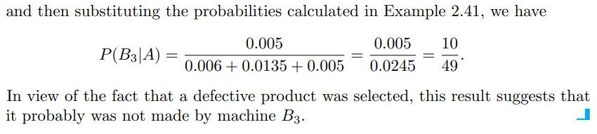

**Example:**

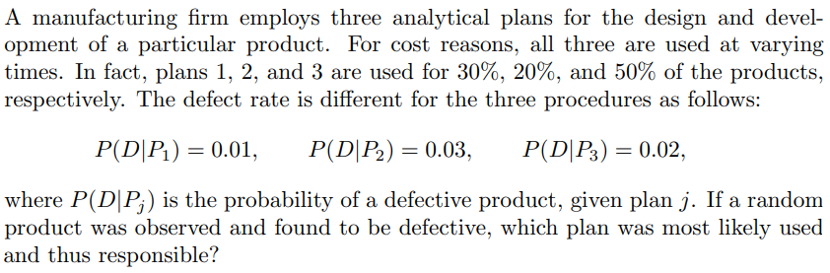

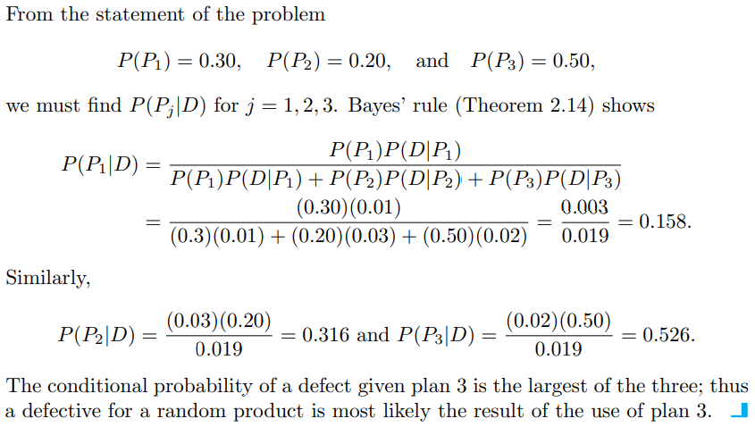

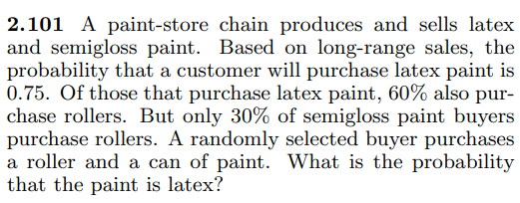

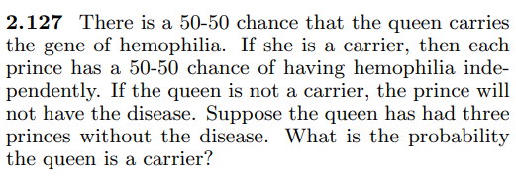

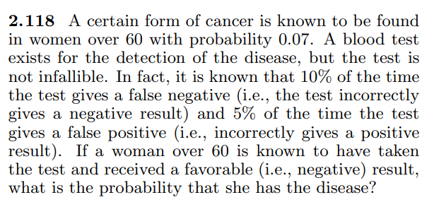

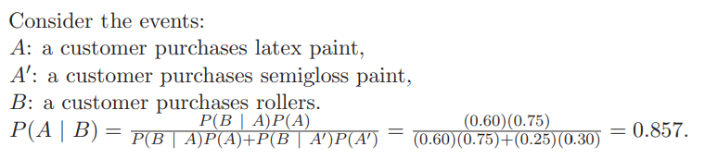

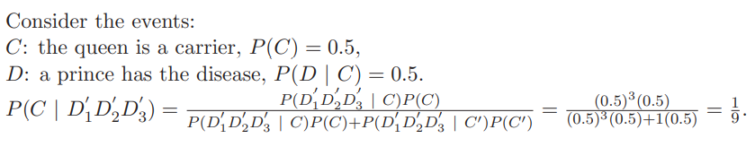

**UNIT-2**



**Example:**

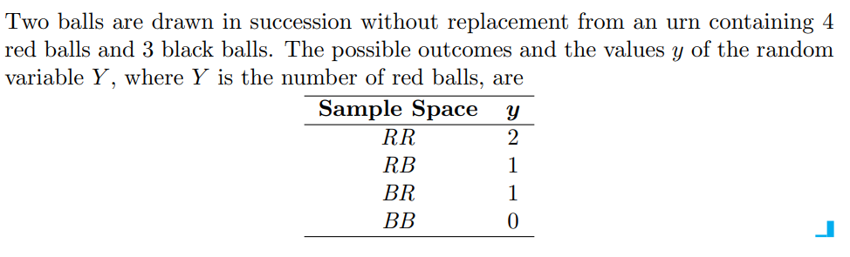

**Example:**

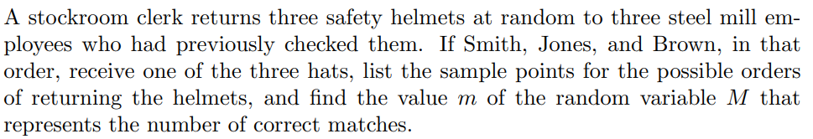

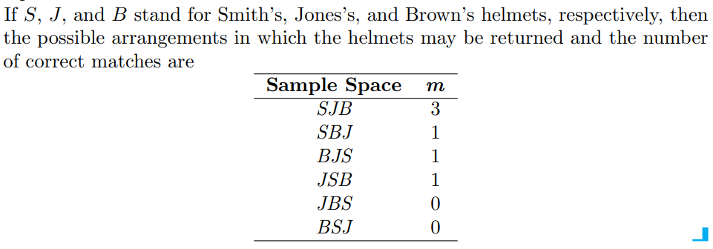

**Example:**

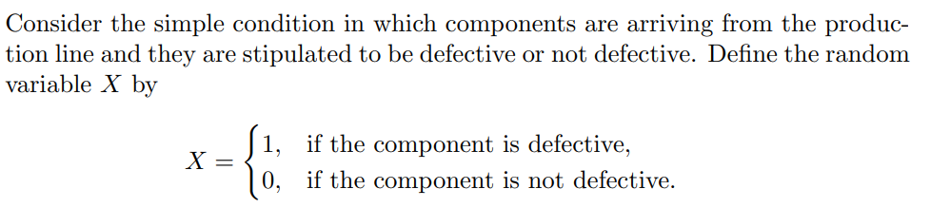

**The random variable for which 0 and 1 are chosen to describe the two possible**

**values is called a Bernoulli random variable.**

**Example:**

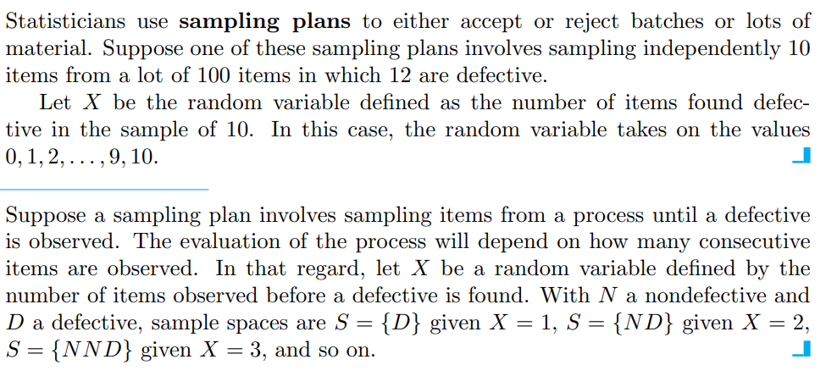

**Example:**

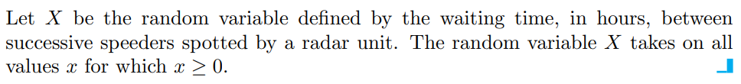

A random variable is called a **discrete random variable** if its set of possible outcomes is countable.

When a random variable can take on values on a continuous scale, it is called a **continuous random variable**.

**Probability Distribution Function**

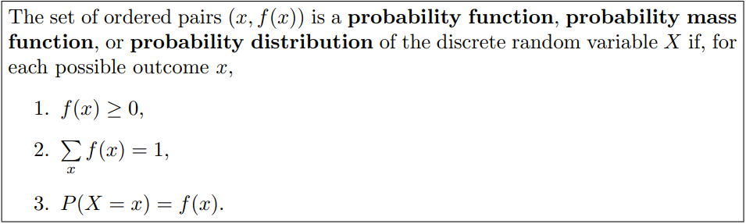

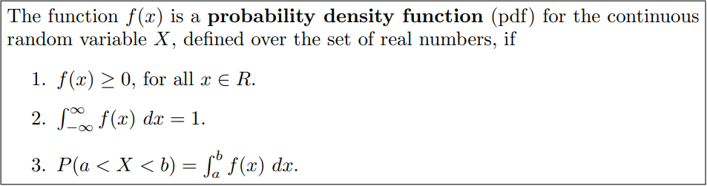

**Example:**

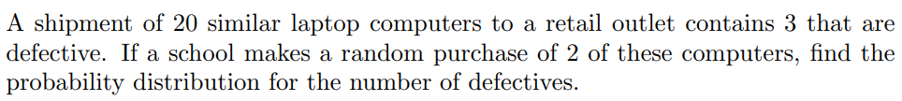



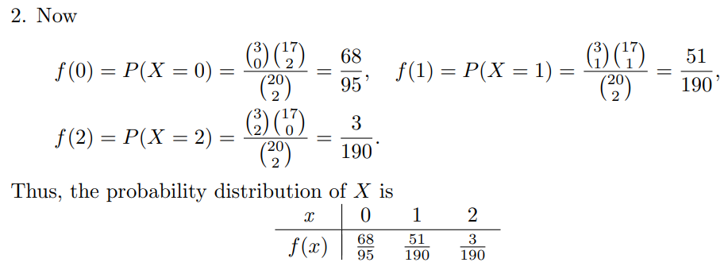

**Example:**

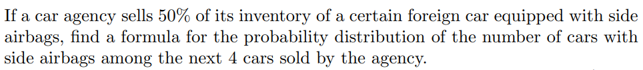

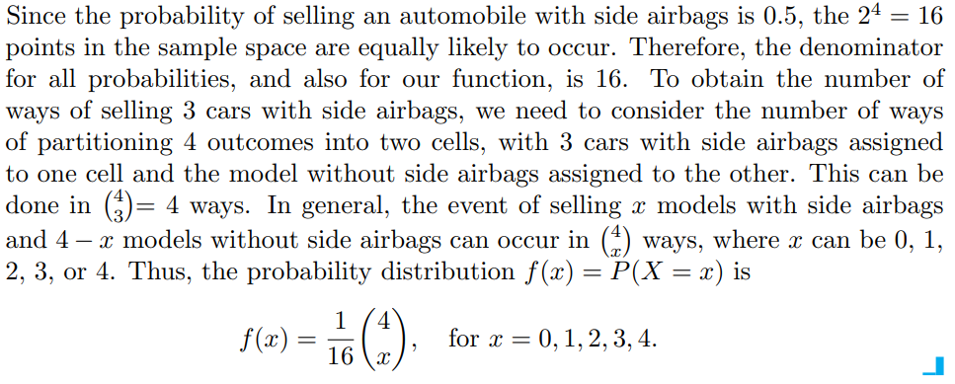

**Example:**

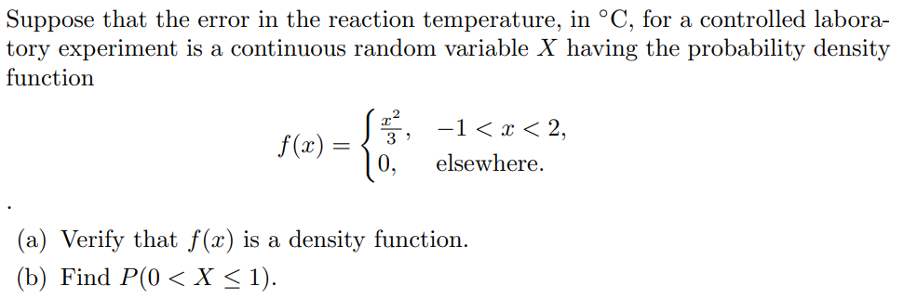

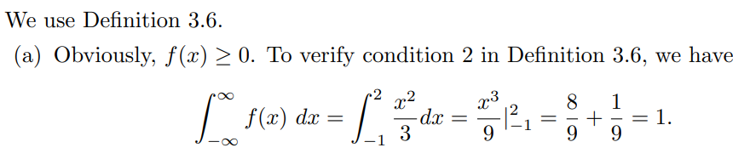

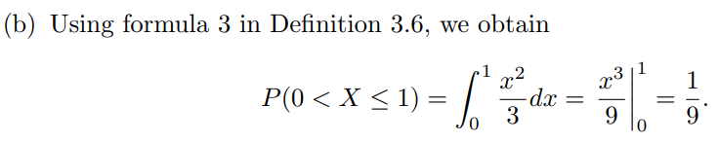

**Note:** When X is a continuous random variable then

$$P\left(a<X<b\right)=P\left(a≤X<b\right)=P\left(a<X≤b\right)=P(a≤X≤b)$$

That is, it does not matter whether we include an endpoint of the interval or not. This is not true, though, when X is discrete.

In fact, if ‘X’ is a continuous random variable then $P\left(X=c\right)=0.$ where $c$ is any constant.

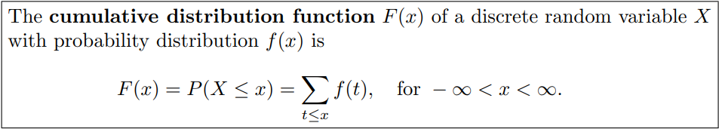

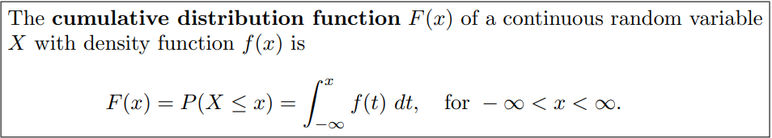

**As an immediate consequence of the above Definition, one can write the two results**

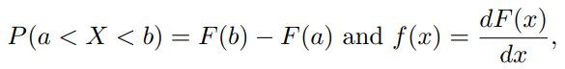

**if the derivative exists.**

**Example:**



Also find the cumulative distribution function of the random variable X.

Using F(x), verify that f(2) = 3/8.



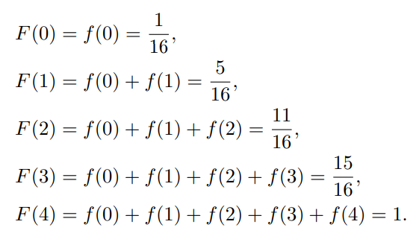 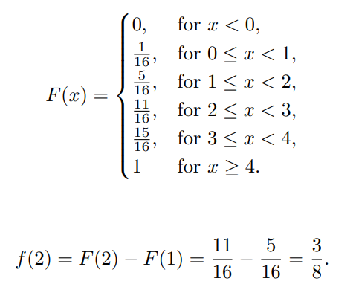

**Example:**



Also find the cumulative distribution function of the random variable M.



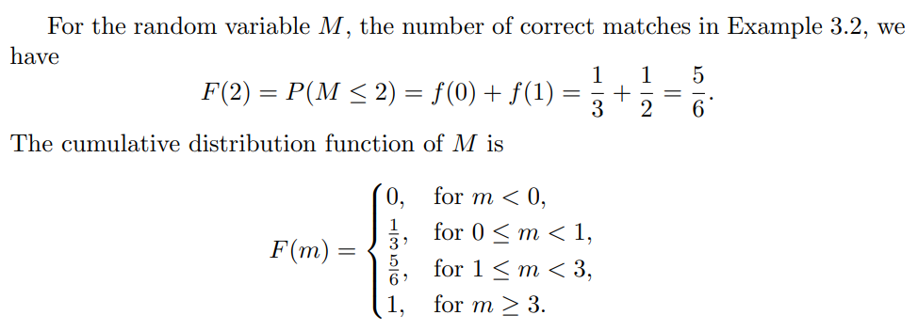

**Example:**



1. Find F(x), and use it to evaluate P(0 < X ≤ 1).

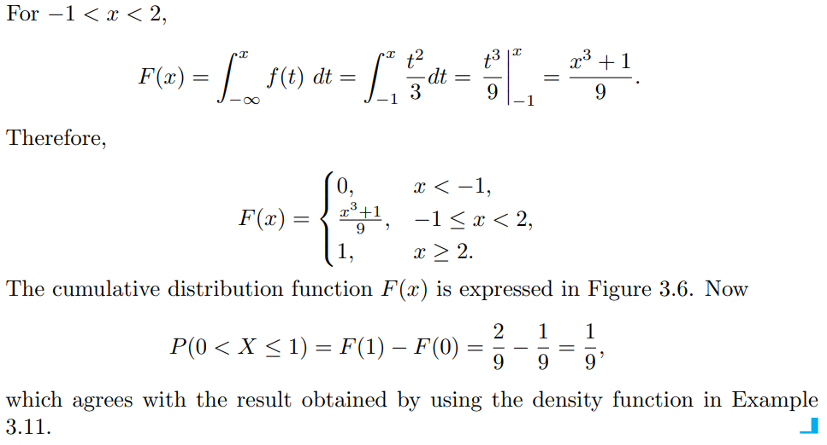

**Example:**

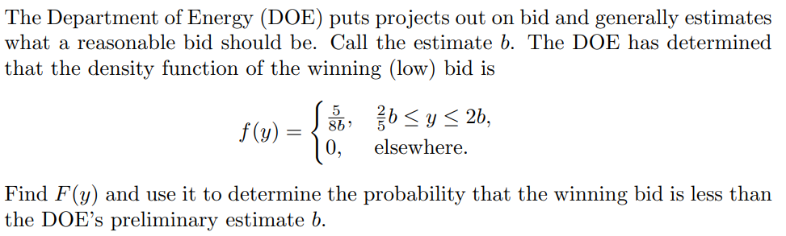

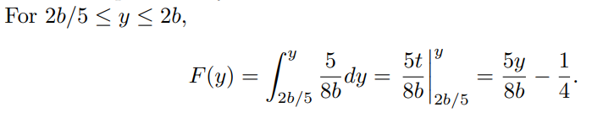

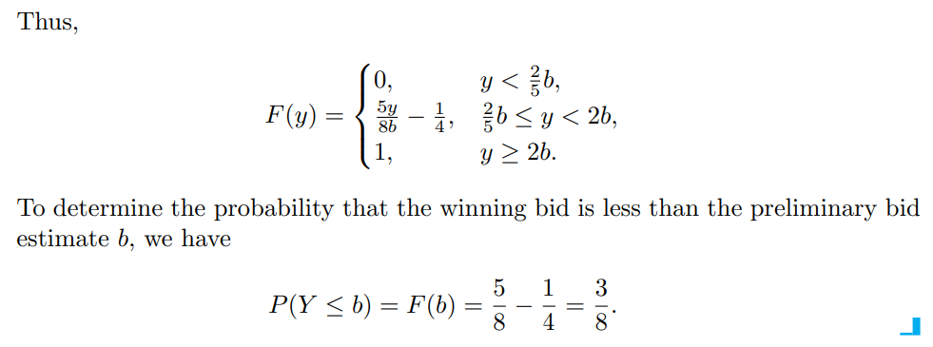

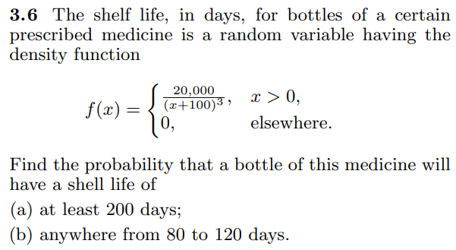 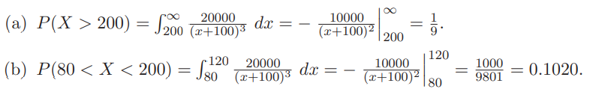

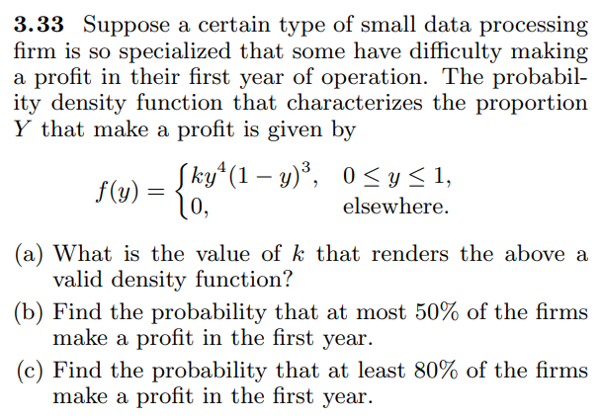

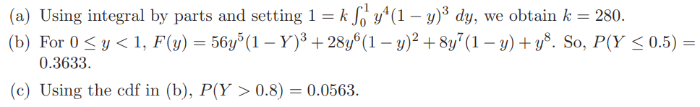

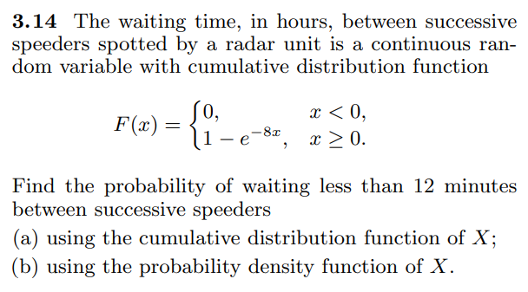

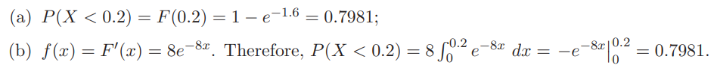

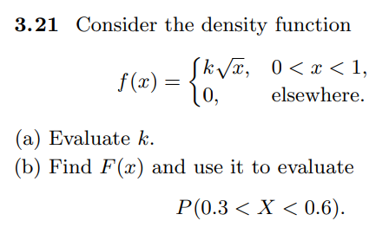

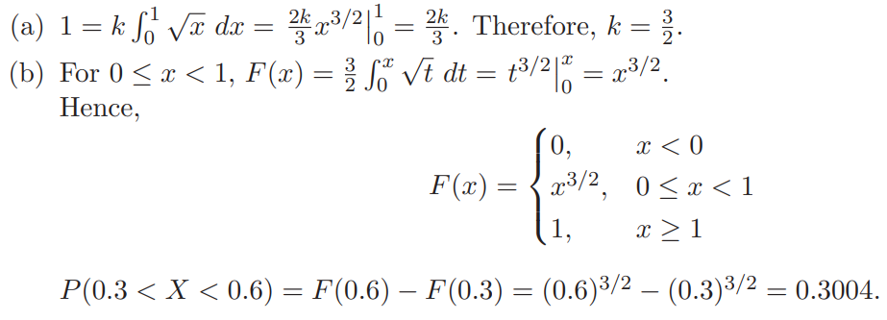

**Example:** If $p\left(x\right)=\left\{\begin{matrix}\frac{x}{15} & ;if x=1,2,3,4,5 \\ 0 & ;elsewhere\end{matrix}\right.$ then find (i) P(X=1 or 2) (ii) $P\left(\frac{1}{2}<X<\frac{5}{2} | X>1\right)$

(a) 1/7                    (b) 2/15                 (c) 1/5                    (d) None of these.

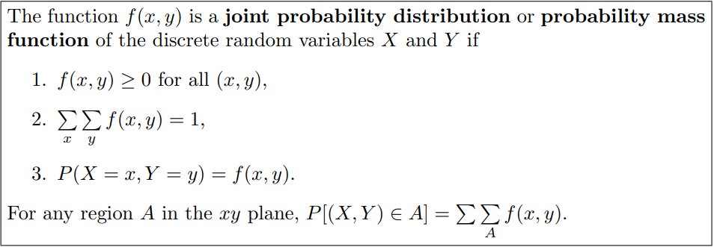

**Example:**

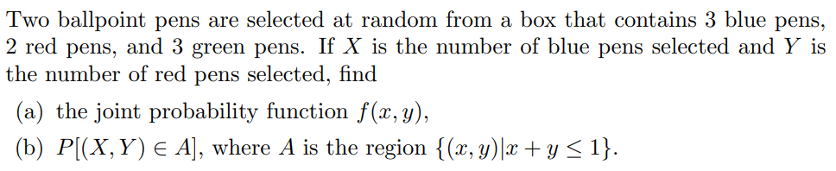

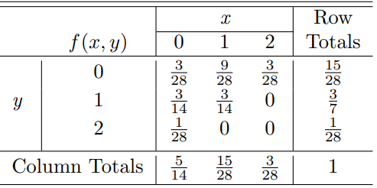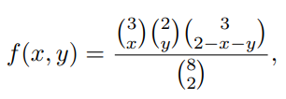

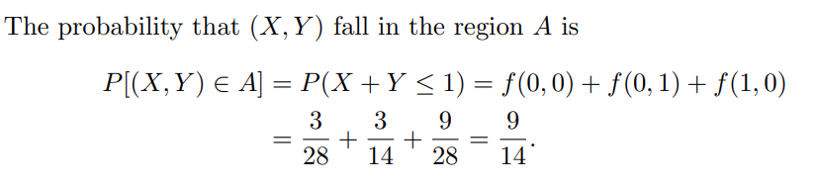

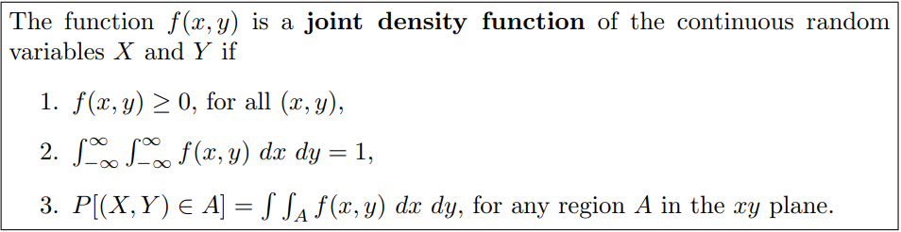

**Example:**

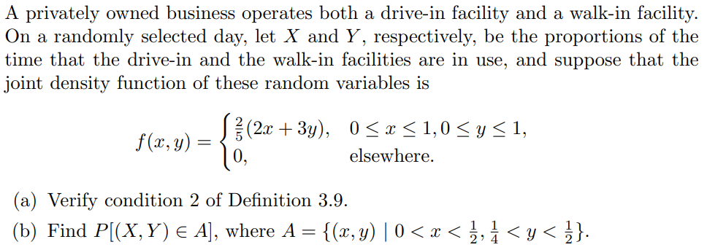

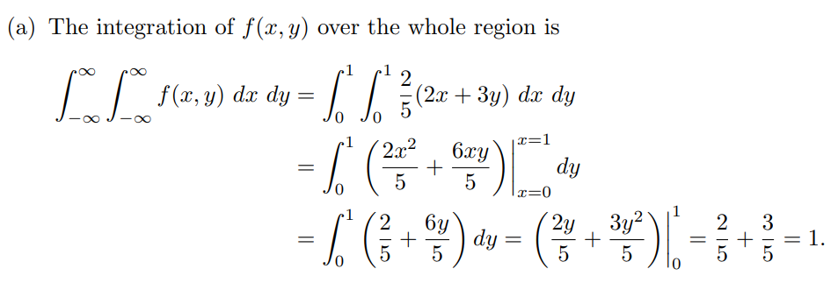

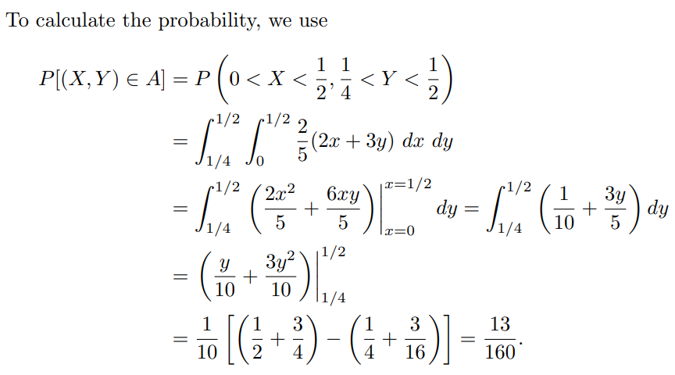

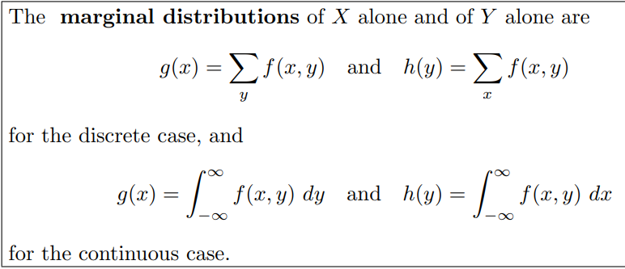

**Example:**





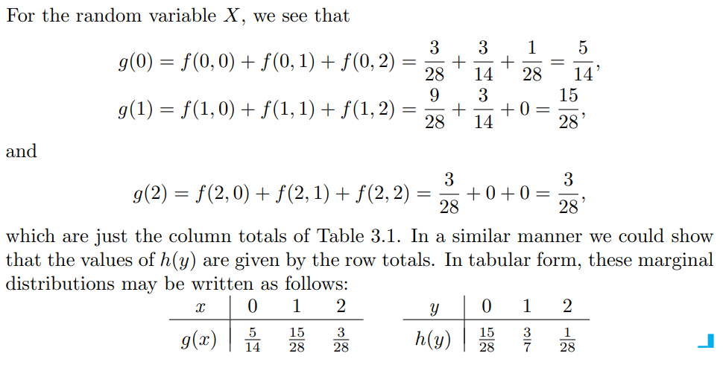

**Example:**



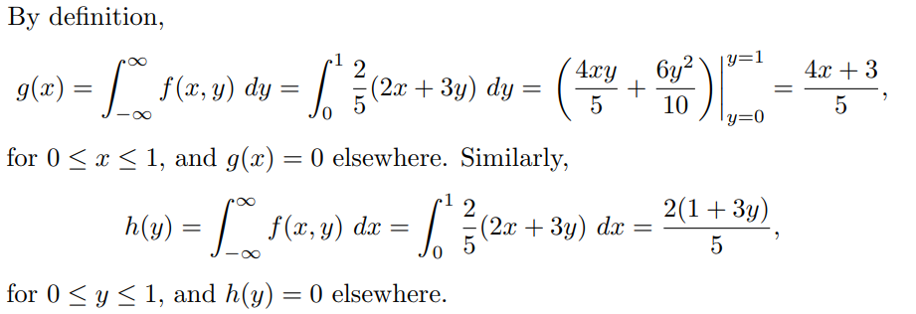

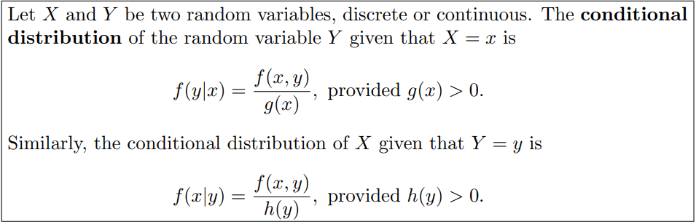

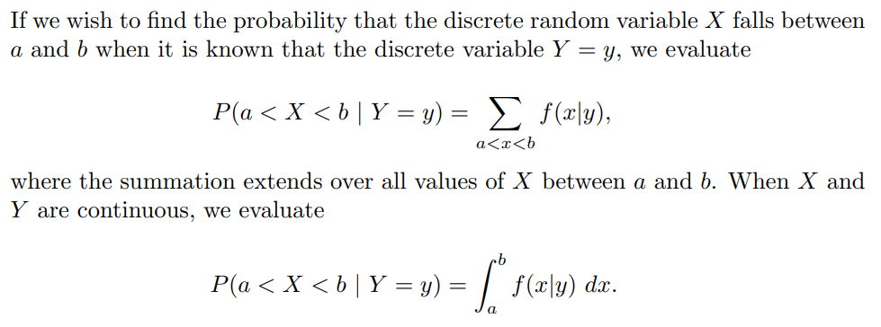

**Example:**



Find the conditional distribution of X, given that Y = 1, and use it to determine P(X = 0 | Y = 1).

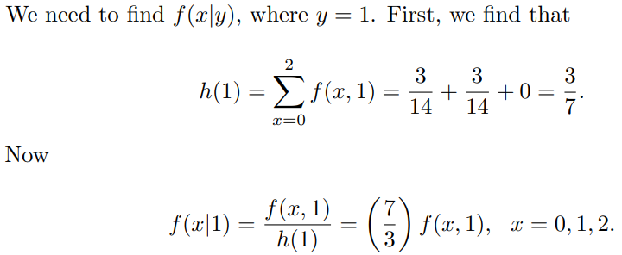



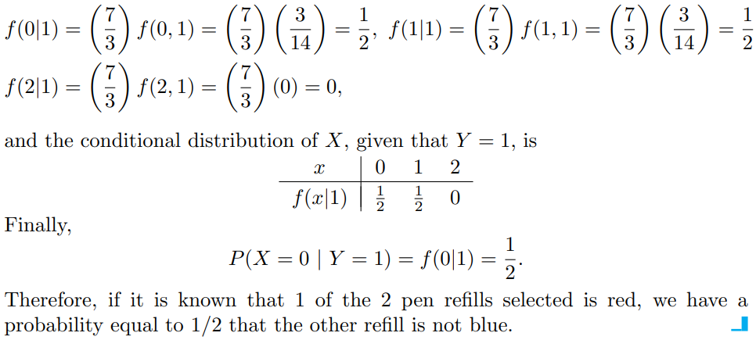

**Example:**

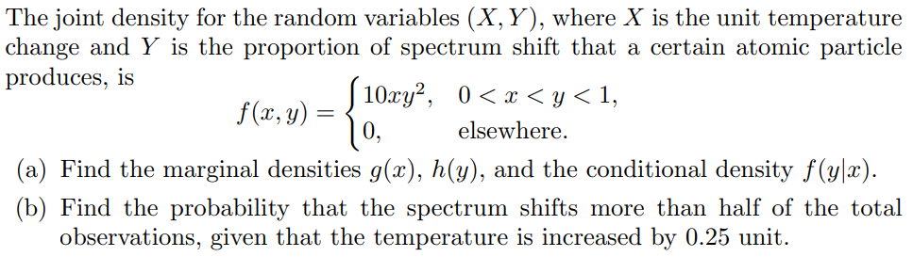

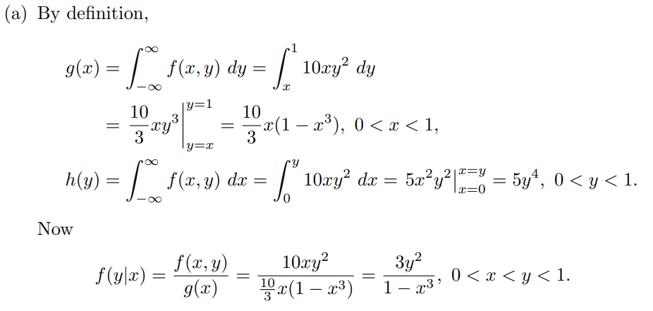

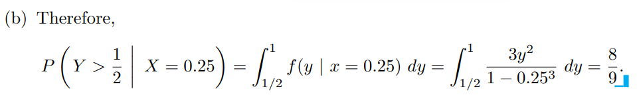

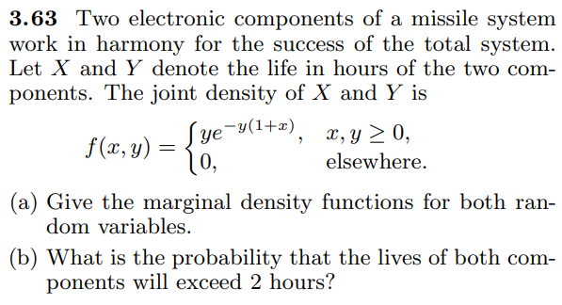

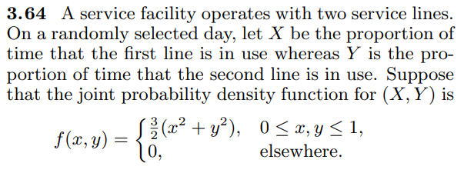 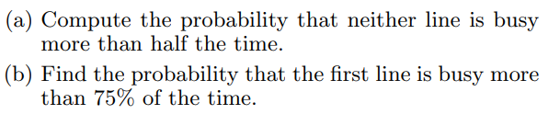

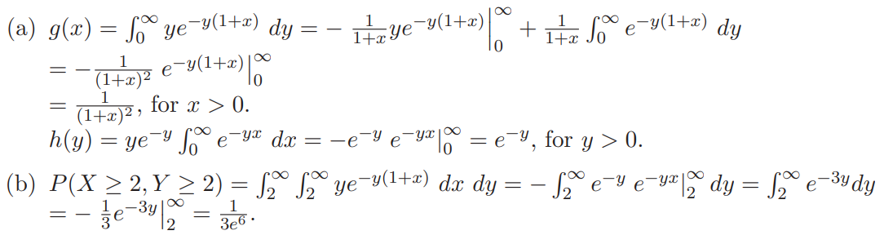

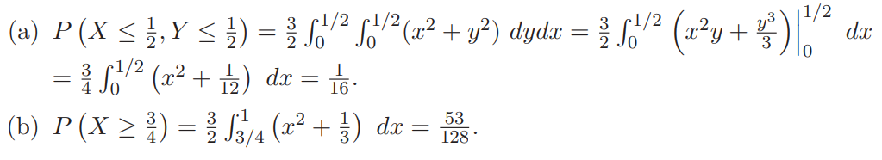

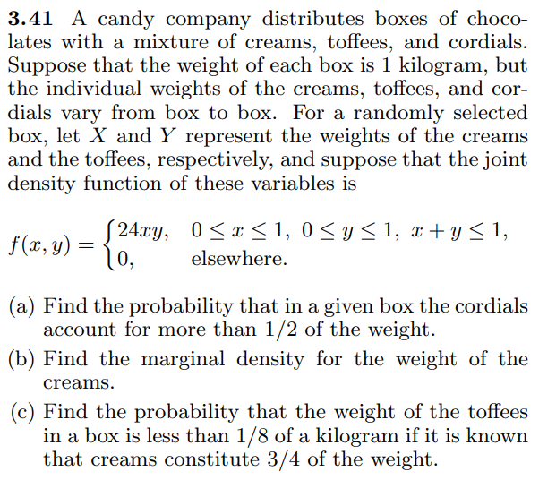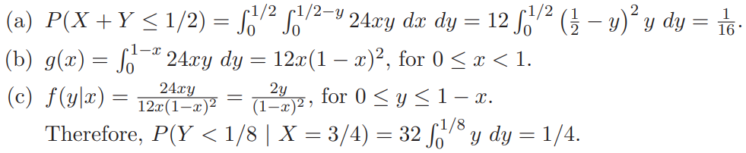

**MATHEMATICAL EXPECTATION**

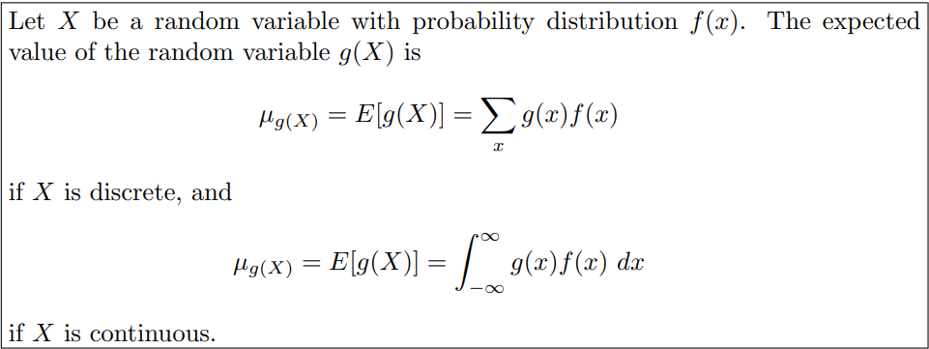

**Remarks:**

$E\left[a_{1}f_{1}\left(X\right)+a_{2}f_{2}\left(X\right)+……+a_{n}f_{n}\left(X\right)\right]=a_{1}{E[f}_{1}\left(X\right)]+a_{2}E\left[f_{2}\left(X\right)\right]+……+a_{n}E[f_{n}\left(X\right)]$

$E\left(c\right)=c$**where ‘ $c$’ is any constant.**

**Example:**

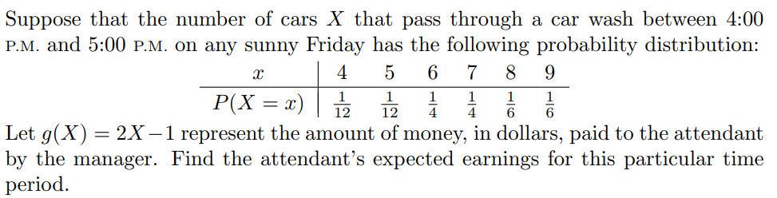

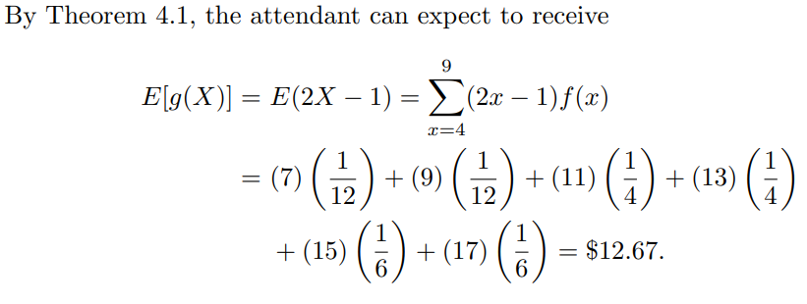

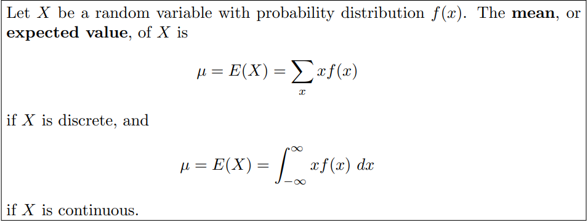

**Example:**

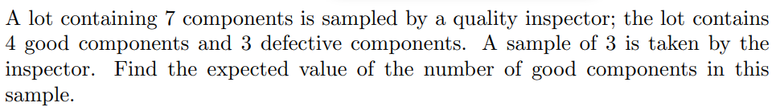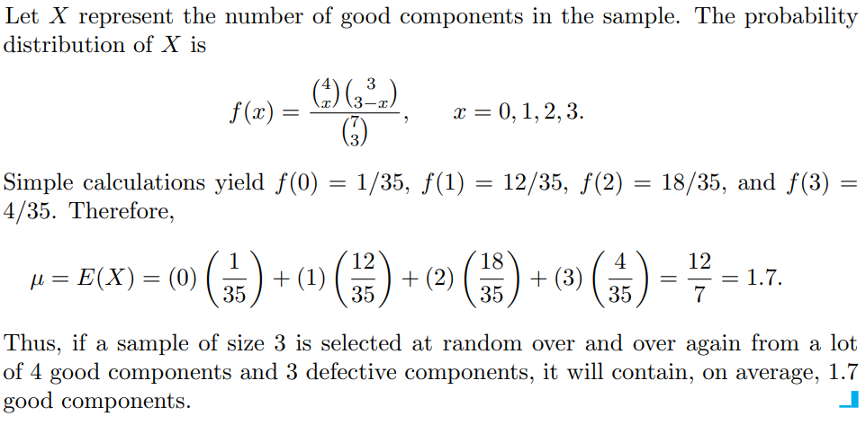

**Example:**

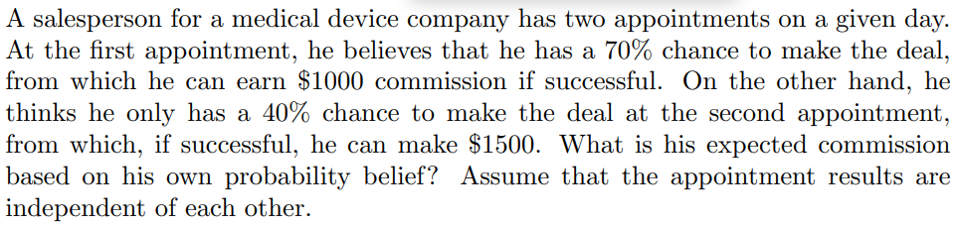

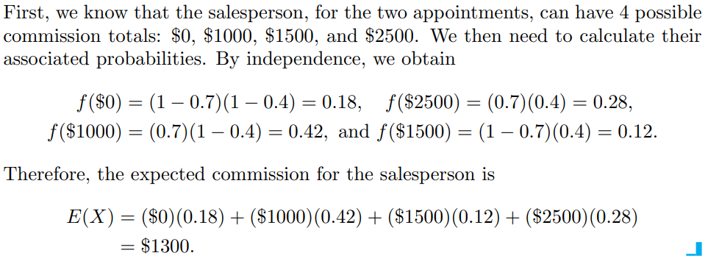

**Example:**

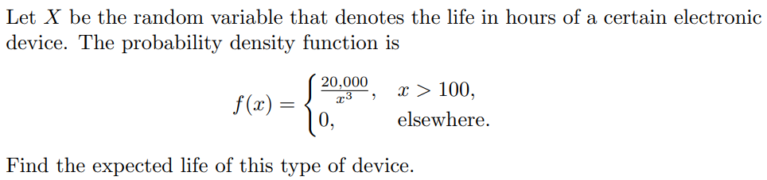

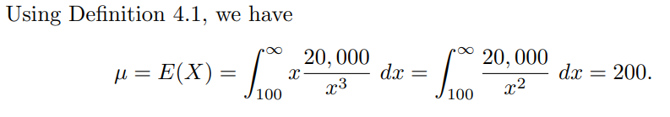 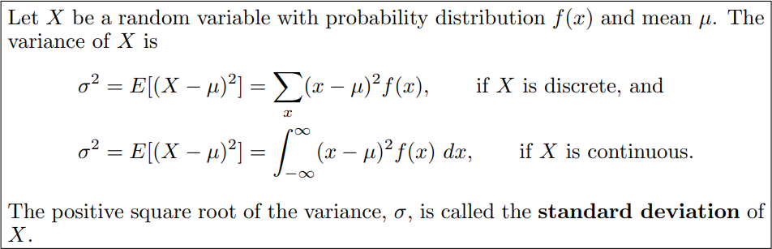

**Example:**

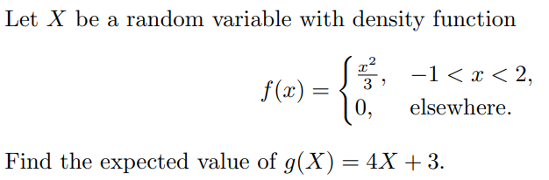

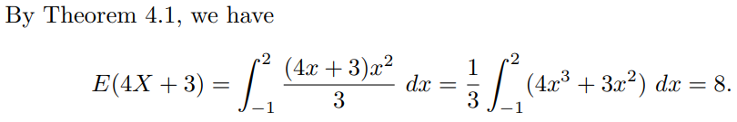

**Example:**

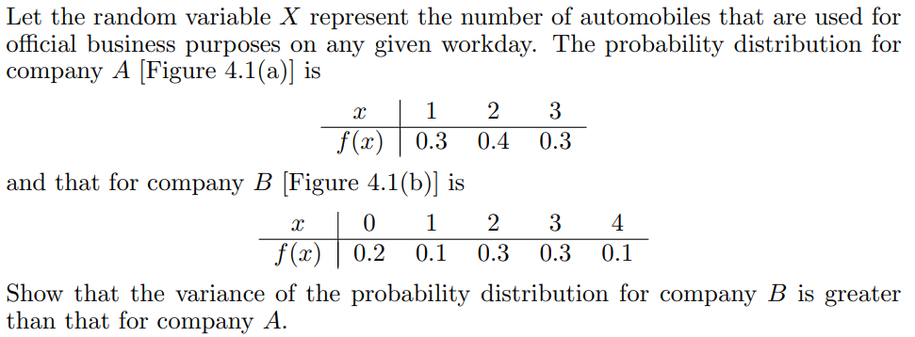

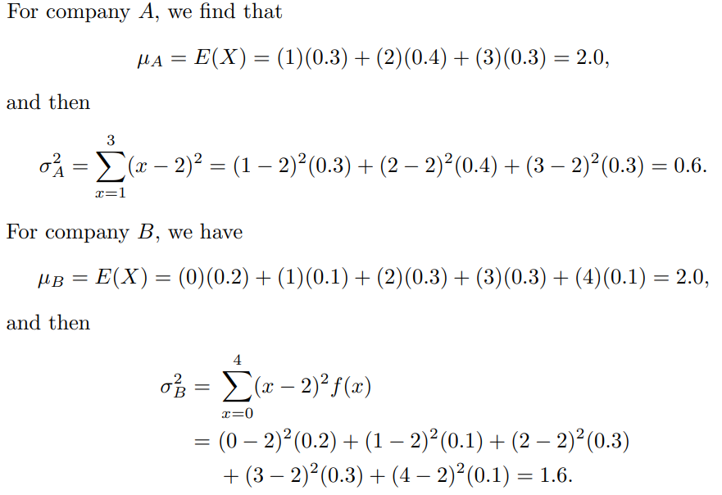

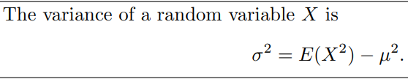

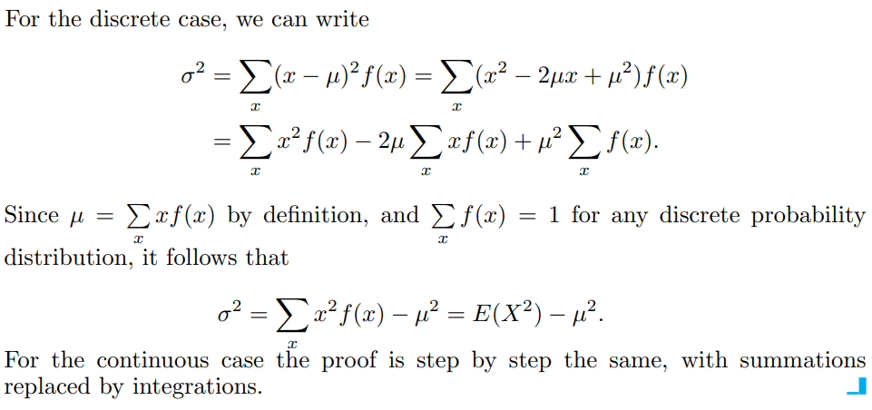

**Example:**

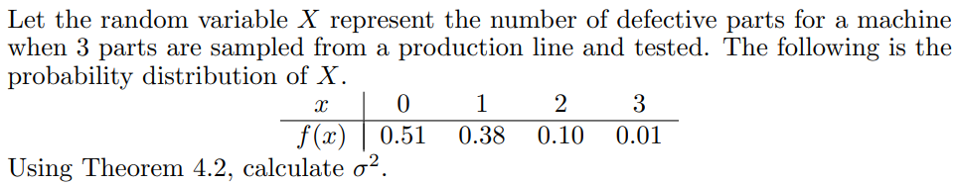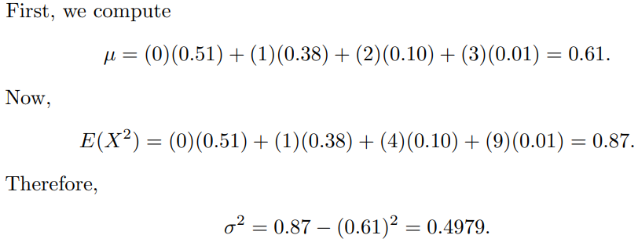

**Example:**

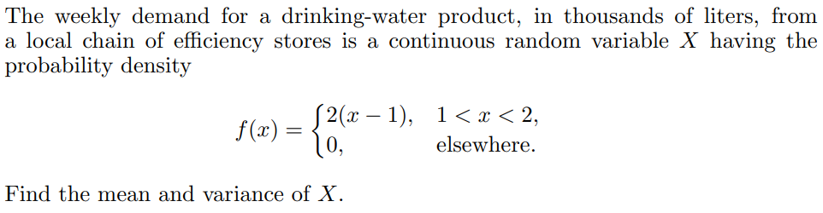

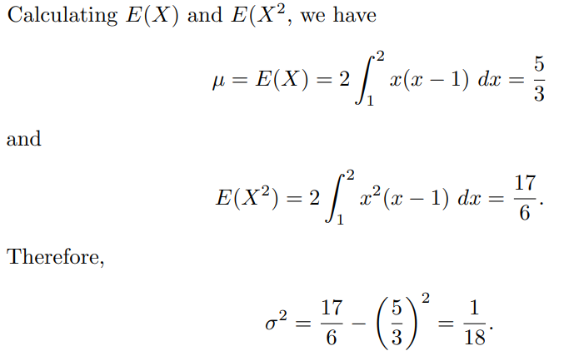

**Example:**

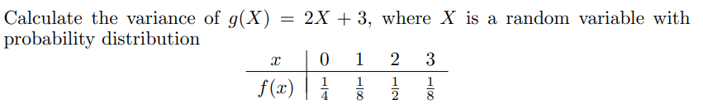

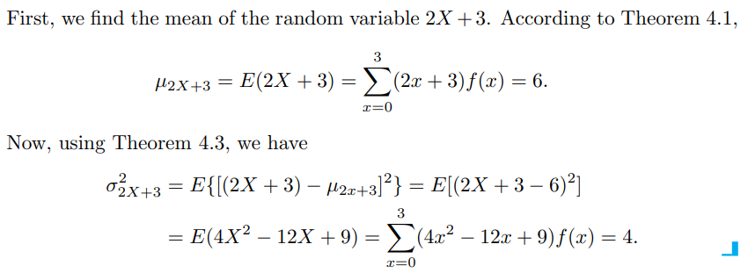

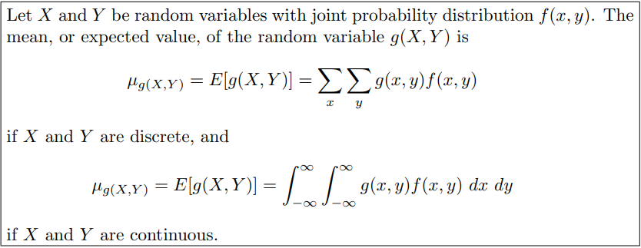

**Example:**

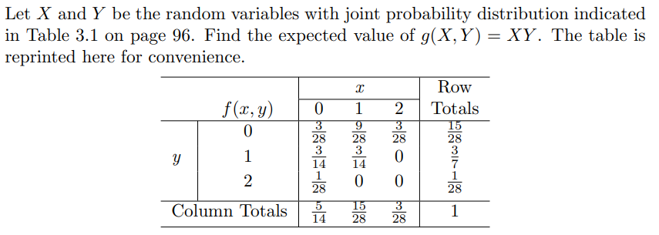

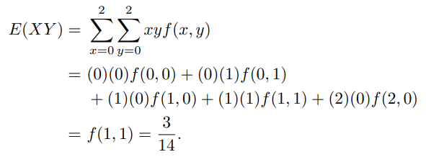

**Example:**

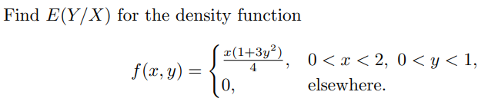 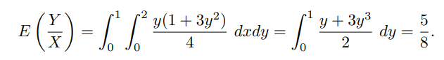

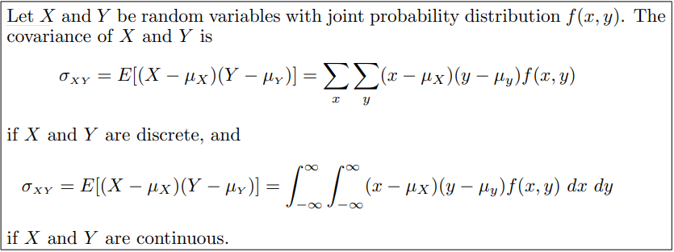

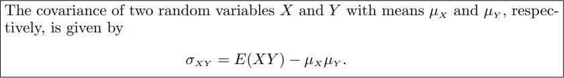

$Cov.\left(X,Y\right)=σ_{XY}=E\left[\left(X-μ_{X}\right)\left(Y-μ_{Y}\right)\right]=E\left[XY-μ_{Y}X-μ_{X}Y+μ_{X}μ_{Y} \right]$

$=E\left[XY\right]-E[μ_{Y}X]-E[μ_{X}Y]+{E[μ}_{X}μ_{Y}]=E\left[XY\right]-μ_{Y}E[X]-μ_{X}E[Y]+μ_{X}μ_{Y}$

$=E\left[XY\right]-μ_{Y}μ_{X}-μ_{X}μ_{Y}+μ_{X}μ_{Y}=E\left[XY\right]-μ_{Y}μ_{X}=E\left[XY\right]-E\left[X\right]E[Y]$

**Note: If the random variables $X$ and $Y$ are independent then $Cov.\left(X,Y\right)=σ_{XY}=0$**

**Since, if the random variables $X$ and $Y$ are independent then $E\left[XY\right]=E\left[X\right]E\left[Y\right].$**

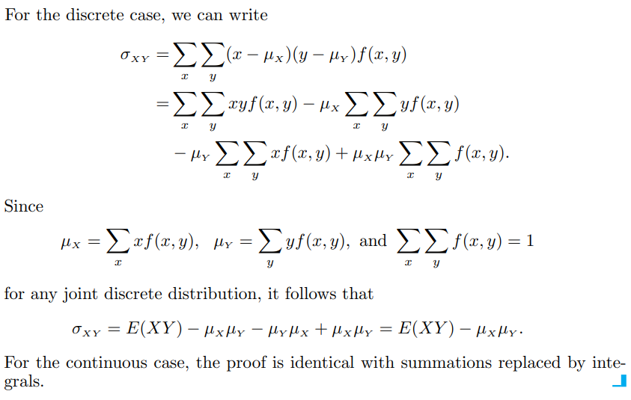

**Example:**



Find the covariance of ‘X’ and ‘Y’.

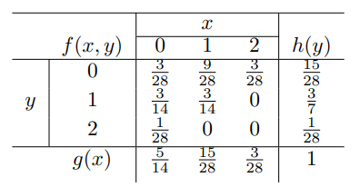

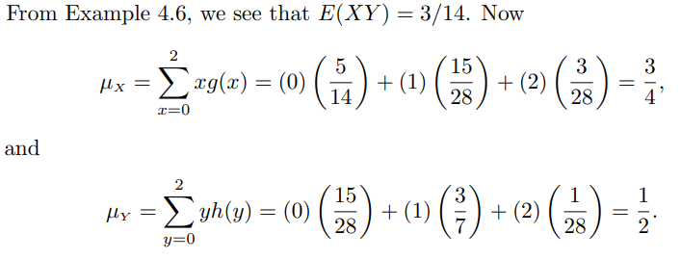

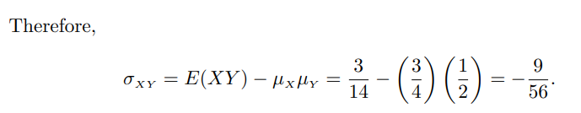

**Example:**

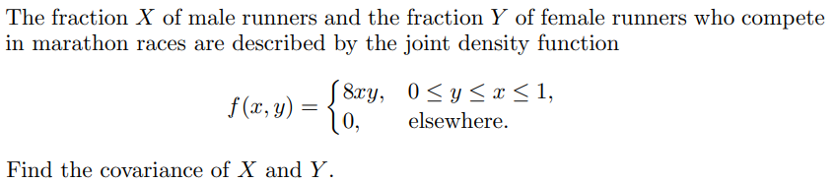

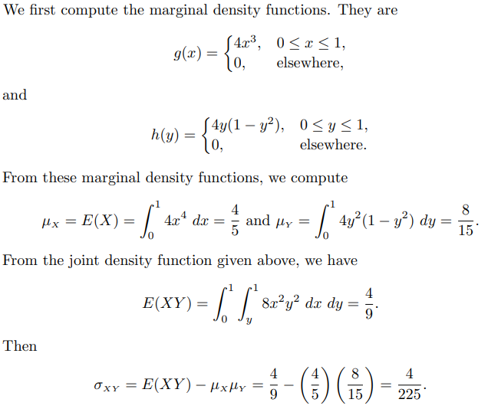

**BINOMIAL DISTRIBUTION**

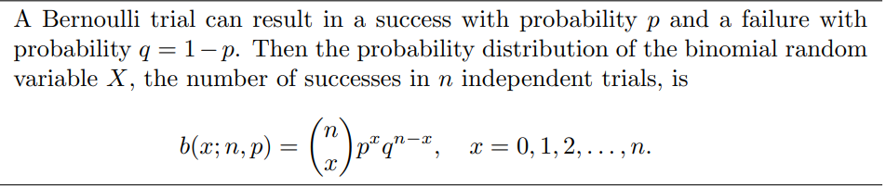

**EXAMPLE:**



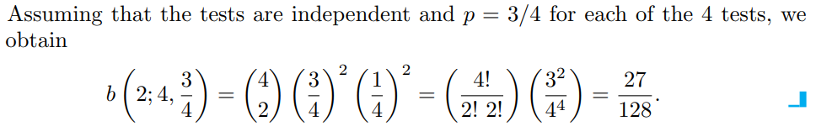

**Where Does the Name Binomial Come From?**

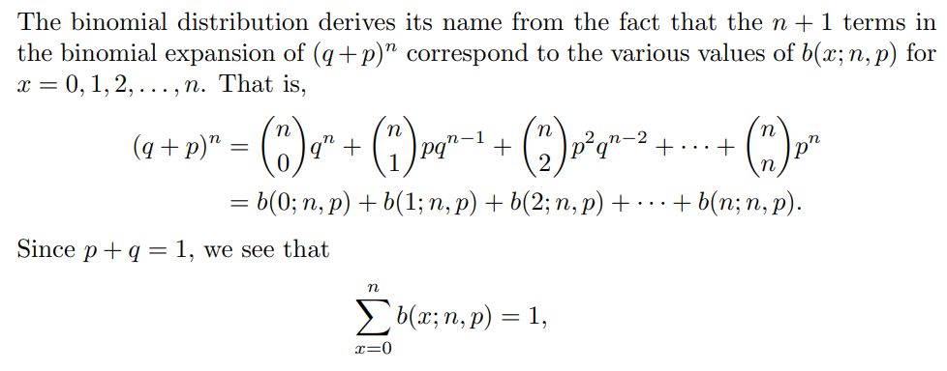

**EXAMPLE:** 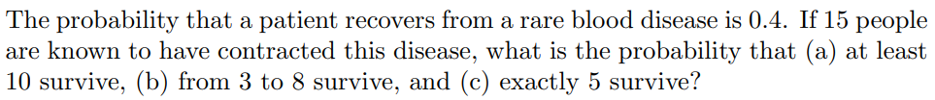

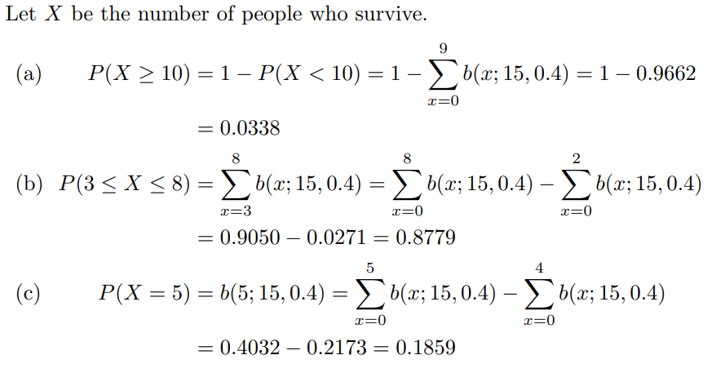

**EXAMPLE:**

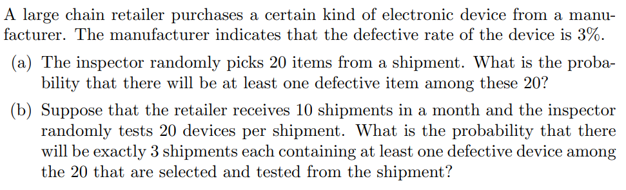

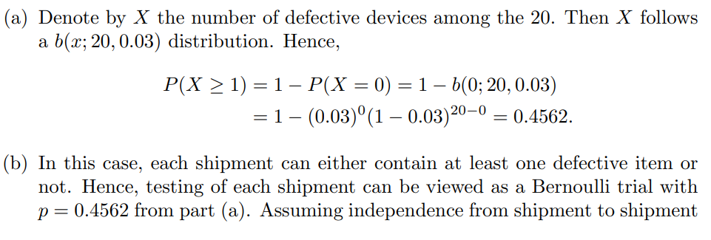

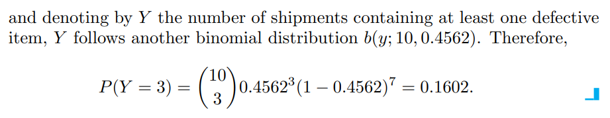

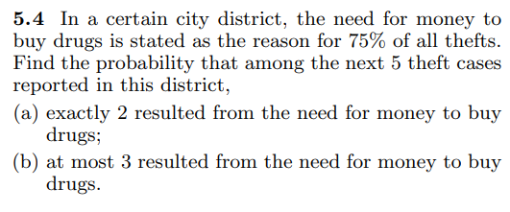

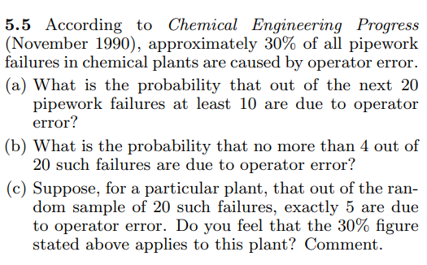

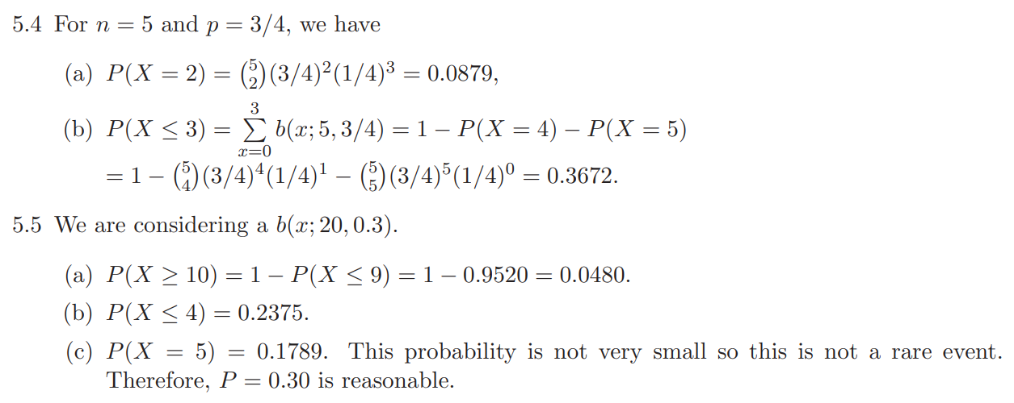

**Result:**



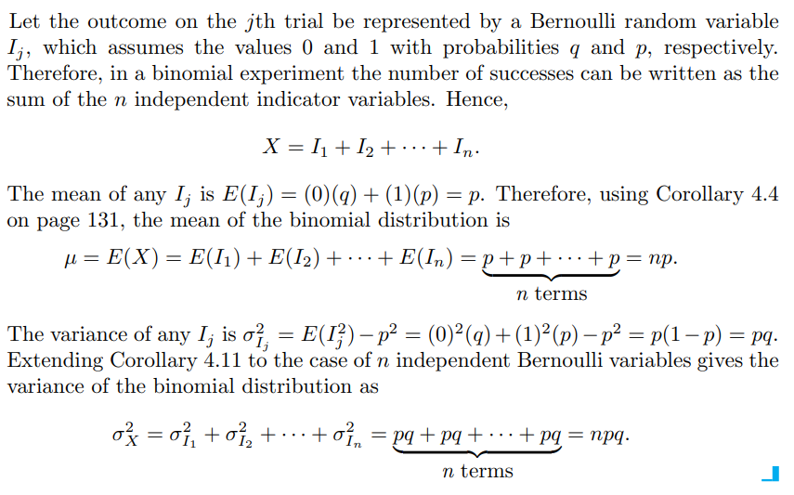

**Example:** In a binomial distribution consisting of five independent trials, probabilities of one success and three failures are 0.4096 and 0.2048 respectively. Then what is the probability of success and failure in a single trial?

(a) $0.5$ and $0.5$ resp. (b) $0.2$ and $0.8$ resp. (c) $0.4$ and $0.6$ resp. (d) $None of these.$

**Negative Binomial Distribution**

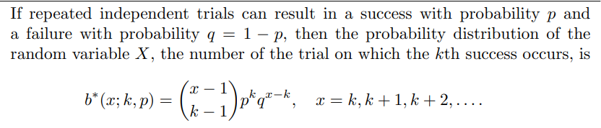

**If there are ‘ $x$’ number of trials for the ‘ $k$’ number of successes then obviously in the first**

$\left(x-1\right)$**number of trials there will be $(k-1)$ number of successes (we denote this event by $E_{1}$)**

**and in the $x^{th}$ trial there will be the last $k^{th}$ success (we denote this event by $E_{2}$).**

**Now, $P\left(E_{1}\right)=\left({x-1 \atop k-1}\right)p^{k-1}x^{x-1-(k-1)}=\left({x-1 \atop k-1}\right)p^{k-1}x^{x-k}$ and $P\left(E_{2}\right)=p$. Therefore the required probability**

**is given by $P\left(E_{1}∩E_{2}\right)=P\left(E_{1})P(E_{2}\right)=\left({x-1 \atop k-1}\right)p^{k-1}x^{x-k}*p=\left({x-1 \atop k-1}\right)p^{k}x^{x-k}.$**

**EXAMPLE:**

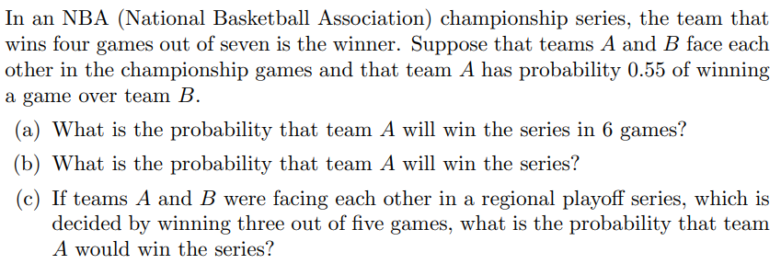

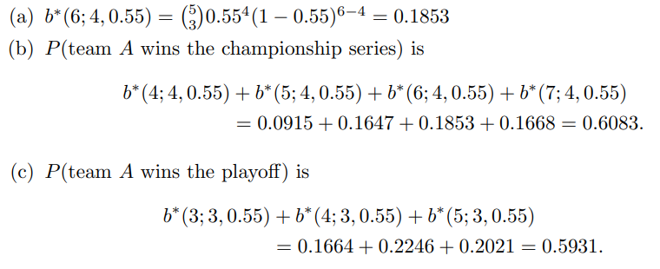

**Geometric Distribution**

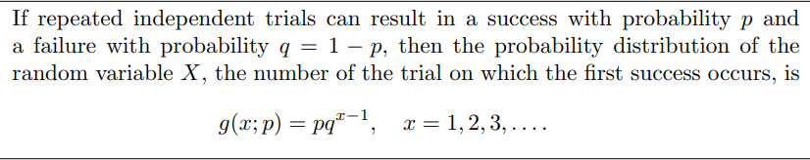

**EXAMPLE:**

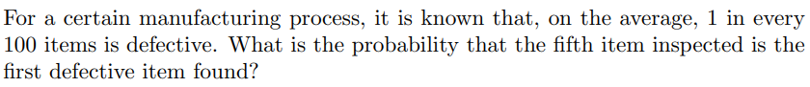

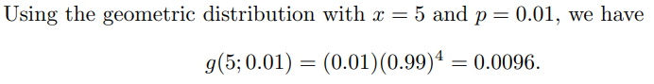

**EXAMPLE:**

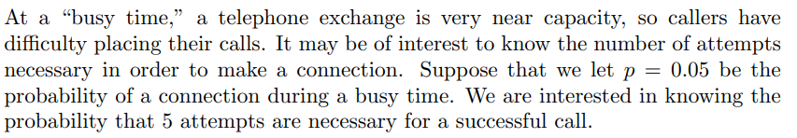

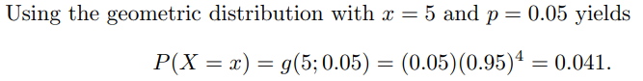

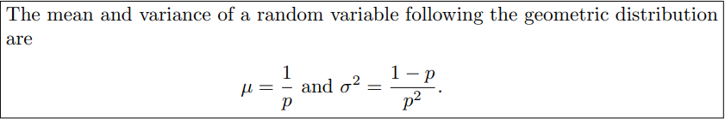

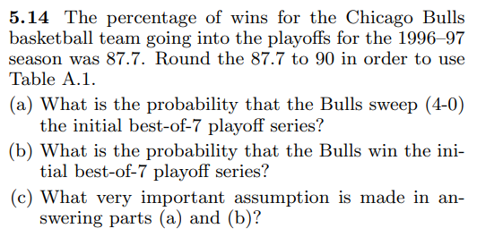

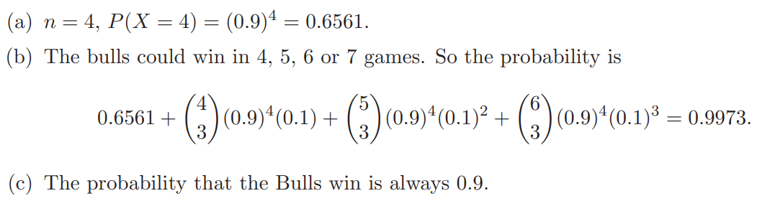

**Poisson Distribution**

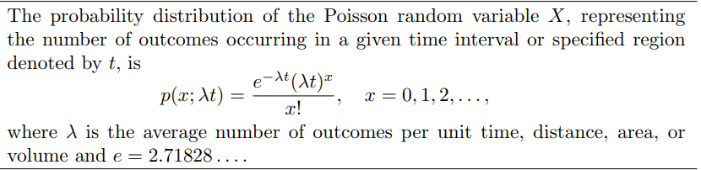

**EXAMPLE:**

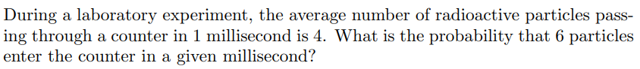

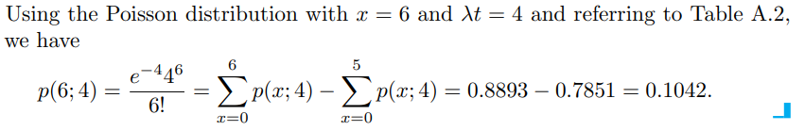

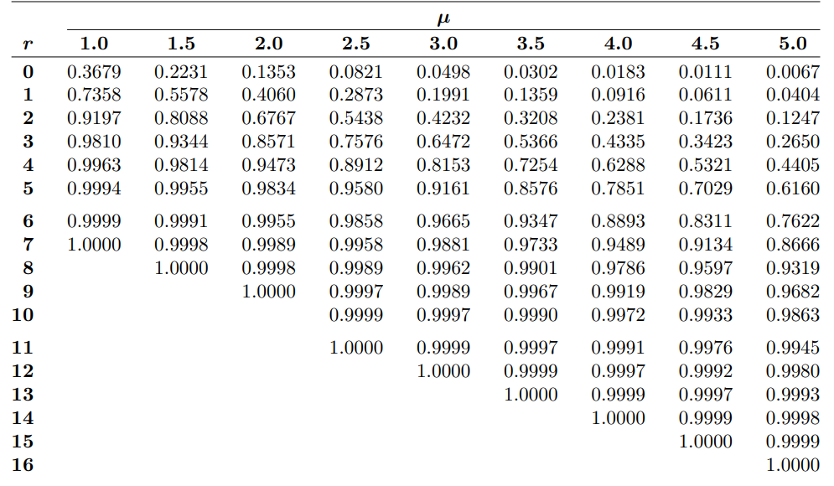

**EXAMPLE:**

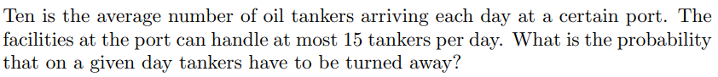

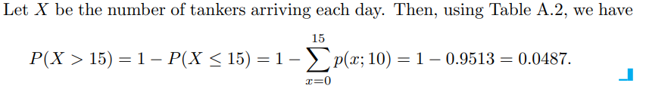



**Result:**

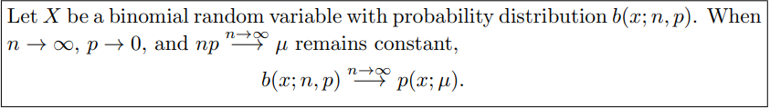

**Proof: We have $b\left(x,n,p\right)=\left({n \atop x}\right)p^{x}q^{n-x}=\frac{n!}{x!\left(n-x\right)!}p^{x}q^{n-x}$ [use $np=μ$ or $p=\frac{μ}{n}$]**

$$=\frac{n\left(n-1\right)\left(n-2\right)\left(n-3\right)…………\left(n-x+1\right)\left(n-x\right)!}{x!\left(n-x\right)!}{\left(\frac{μ}{n}\right)}^{x}{\left(1-\frac{μ}{n}\right)}^{n-x}$$

$$=\frac{n\left(n-1\right)\left(n-2\right)\left(n-3\right)…………\left(n-x+1\right)}{x!}{\left(\frac{μ}{n}\right)}^{x}{\left(1-\frac{μ}{n}\right)}^{n-x}$$

$$=\frac{\frac{n}{n}\frac{\left(n-1\right)}{n}\frac{\left(n-2\right)}{n}\frac{\left(n-3\right)}{n}…………\frac{\left(n-x+1\right)}{n}}{x!}{\left(μ\right)}^{x}{\left(1-\frac{μ}{n}\right)}^{n-x}$$

$$=\frac{1\left(1-\frac{1}{n}\right)\left(1-\frac{2}{n}\right)\left(1-\frac{3}{n}\right)…………\left(1-\frac{x-1}{n}\right)}{x!}{\left(μ\right)}^{x}\frac{{\left(1-\frac{μ}{n}\right)}^{n}}{{\left(1-\frac{μ}{n}\right)}^{x}}$$

**Now taking limit as $n→∞$ on both side and using the result that $\lim_{n→∞}{{\left(1+\frac{k}{n}\right)}^{n}=e^{k}}$ we get**

$b\left(x,n,p\right)→\frac{μ^{x}e^{-μ}}{x!}=p\left(x,μ\right).$ Hence Proved.

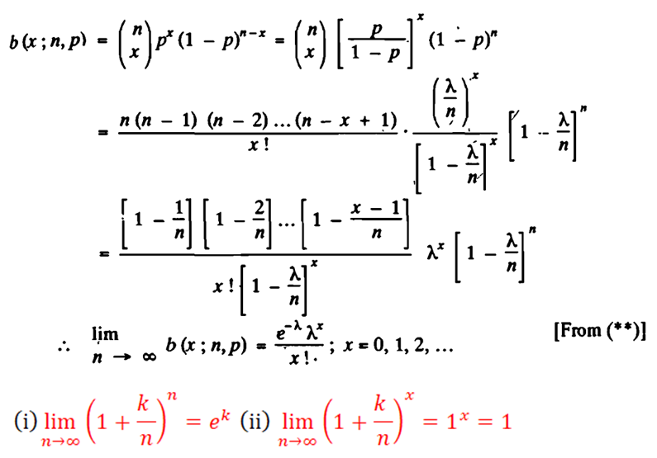

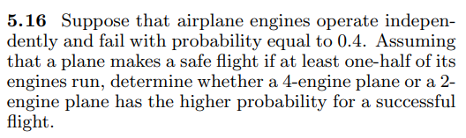

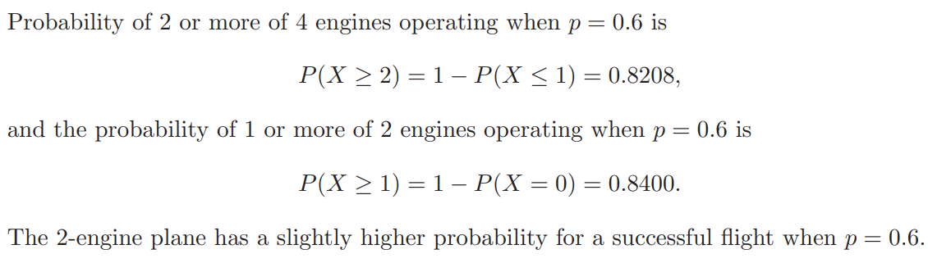

**Example:**

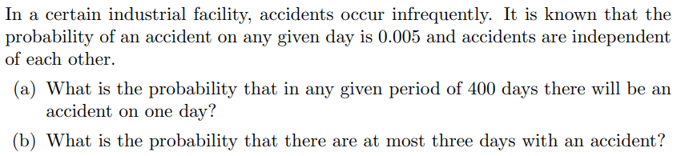

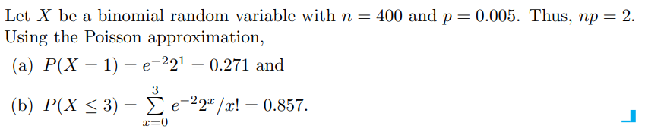

**Example:**

